relational model

it is a model designed by a famous data scientist named edgar frank codd
in relational model we store data in form of rows(also called records, tuples) and columns(also called attributes/properties, fields ) (table format)

cells

Columns – it describes single property of all entity
Rows – it describes multiple properties of a single entity
Cell – it is a smallest unit of a table or intersection between rows and columns generates a space where we store data is called cell.

Rules of E.F. Codd
- The data entered into a cell must be single value data.
- In r dbms we can store everything in form of table including meta data (meta table)
- According to E.F. Codd we can store data in multiple tables if it is needed, we can establish connection between the tables using key attributes.
- The data entered into a table must be validated in 2 ways first by assigning data type and second by assigning constraints.

Data Type
It is used to describe what kind of data we are going to store in a particular column or a memory location.
- CHAR – ‘A-Z’ , ‘a-z’ , ‘0-9’ , sp.character
- VARCHAR / VARCHAR2
- NUMBER (only in oracle SQL other will use INTEGER & FLOAT)
- DATE
- LARGE OBJECT
- CHARACTER LARGE OBJECT
- BINARY LARGE OBJECT
Constraints
Constraints are the rules given to a column to validate the data.
- UNIQUE
- Not NULL
- CHECK
- PRIMARY KEY
- FOREIGN KEY
- DEFAULT

For phone number column PH_NO
NUMBER(10), UNIQUE, NOT NULL, CHECK(LENGTH(PH_NO)=10), CHECK(PH_NO>0)

PRIMARY KEY: It is a constraint used to uniquely identify records from the table.
Characteristics:
- We can have only one primary key in a table.
- It will not accept duplicated/repeated values.
- It will not accept Null values.
- It is a combination of UNIQUE and NOT NULL constraint.
- It is not mandatory but highly recommended.
FOREIGN KEY: A Foreign Key is a constraint used to link two tables together. It is a field (or collection of fields) in one table that refers to the Primary Key in another table. It is technically known as a referential integrity constraint because it ensures the validity of the relationship between the data.
Characteristics:
- We can have multiple foreign key in a table.
- It will accept duplicated/repeated values.
- It will accept Null values.
- It is not a combination of UNIQUE and NOT NULL constraint.
- For an attribute to become a foreign key first it should be primary key in its ow table.
- It is also known as referential integrity constraints.

PRODUCTS (parent table)
PRIMARY KEY NOT NULL
PID | PNAME
P1 | OPPO
P2 | VIVO

EMP (child table)
FOREIGN PRIMARY KEY NOT NULL NOT NULL CHECK(SAL>0) FOREIGN KEY NOT NULL KEY
PID | EMPNO | ENAME | HIREDATE | SAL | DEPTNO
P1 | 101 | ROHAN | 21-JAN-20 | 20000 | 10
P2 | 102 | MOHAN | 21-JAN-20 | 30000 | 10
P2 | 103 | SOHAN | 21-JAN-22 | 25000 | 20
 | 104 | JOHAN | 21-JAN-21 | 65000
P1 | 105 | GOKU | 21-JAN-25 | 40000 | 30

DEPT (parent table)
PRIMARY KEY NOT NULL NOT NULL
DEPTNO | DNAME | LOC
10 | D1 | L1
20 | D2 | L2
30 | D3 | L3
40 | D4 | L4

SQL Statements
- Data definition language (DDL)
- CREATE
- RENAME
- ALTER
- TUNCATE
- DROP
- Data manipulation language (DML)
- INSERT
- UPDATE
- DELETE
- Transaction control language (TCL)
- COMMIT
- ROLLBACK
- SAVEPOINT
- Data control language (DCL)
- GRANT
- REVOKE
- Data query language (DQL)
- SELECT
- PROJECTION
- SELECTION
- JOINS

DQL Statements
- SELECT: This statement is used to retrieve the data from the tables and display it.
- PROJECTION: This statement is used to retrieve the data from the table by selecting only columns.
- SELECTION: This statement is used to retrieve the data from the table by selecting both rows & columns.
- JOINS: This statement is used to retrieve the data from multiple table simultaneously.

Projection
Syntax: SELECT */[DISTINCT] Column_name/Expression[ALIAS]
FROM Table_name;
Order of execution: 1. FROM clause
2. SELECT clause

STUDENT
SID | SNAME | AGE
101 | A | 22
102 | B | 23
103 | C | 24
104 | D | 25

Write a query to display all name of the students.
SELECT SNAME
FROM STUDENT;

ALIAS
- It is an alternative name given to a column or expression in the result table.
- It can be used with or without AS keyword.
- ALIAS names should be single word or it should be enclosed within double quotes or we can use underscore if it is having multiple words.
- It is not mandatory but highly recommended.
DISTINCT
- Distinct is a clause which is used to remove duplicated or repeated values from the table.
- For DISTINCT clause we can pass column name or an expression as an argument.
- We can pass DISTINCT clause in the select clause as a first argument.
- We can pass multiple column to distinct clause it will remove duplicated or repeated values in combination.
SELECTION: "It is used to retrieve the data from the table by selecting both rows & columns."
SYNTAX:
SELECT * / [DISTINCT] COLUMN_NAME/EXPRESSION[ALIAS]
FROM TABLE_NAME
WHERE <FILTER_CONDITION>;
ORDER OF EXECUTION:
1. FROM
2. WHERE
3. SELECT

STUDENT
SID | SNAME | AGE
101 | A | 22
102 | B | 23
103 | C | 24
104 | D | 25

OPRATORS
- Arithmetic operators (+, -, *, /)
- Relational operators (>, <, >=, <=)
- Logical operators (AND, OR, NOT)
- Comparison operators (=, !=, <>)
- Special operators (IN, NOT IN, BETWEEN, NOT BETWEEN, IS, IS NOT, LIKE, NOT LIKE)
- Subquery operators (ALL, ANY, EXISTS, NOT EXISTS)
- Concatenation operators (||)

Logical operators (AND, OR, NOT)
AND: it is used whenever we want to satisfy all the conditions.
Syntax: AND
WHERE CONDITION1 AND CONDITION2 AND CONDITION3………..;

OR: it is used to whenever we want to satisfy any one of the condition
Syntax: OR
WHERE CONDITION1 OR CONDITION2 OR CONDITION3………..;

NOT: it used to inverse or reject a condition
Syntax: NOT
WHERE NOT CONDITION;

Special operators
IN: it is a multi-valued operator which is used to accept multiple values at RHS, it is similar to equals operators it returns true if it satisfied any one of the values present at RHS.
Syntax: IN()
WHERE col_name/exp IN(v1,v2,v3…..vn)
Ex- DEPTNO IN (10,20,30,40)

NOT IN: it is similar to in oprator but instead of accepting it will reject the values
Syntax: NOT IN()
WHERE col_name/exp NOT IN(v1,v2,v3…..vn)
Ex- DEPTNO IN (10,20,30,40)

BETWEEN: it is used whenever we have range of values, it works by including the given range, we can not interchange the range of values
Syntax: BETWEEN
WHERE col_name/exp BETWEEN ‘STARTING-RANGE’ AND ‘ENDING_RANGE’

Joins
"The process of retrieving the data from the multiple table simultaneously is known as joins." TYPE OF JOIN: -
  - CARTESIAN JOIN / CROSS JOIN
  - INNER JOIN / EQUI JOIN
  - NATURAL JOIN
  - SELF JOIN
  - OUTER JOIN
    - Left outer join
    - Right outer join
    - Full outer join

CARTESIAN JOIN/CROSS JOIN: -
"In Cartesian join a record of table 1 will merge with all the records of table2."
All row of table 1 will be joined with each row of table 2
SNYTAX: -
ANSI
SELECT COLNAME/EXP
FROM TABLENAME1 CROSS JOIN TABLENAME2;

ORACLE
SELECT COLNAME/EXP
FROM TABLENAME1, TABLENAME2;
INNER JOIN / EQUI JOIN: -
"It is used to obtain only matching records."
SYNTAX: -
ANSI (Standard SQL)
SELECT COLNAME / EXP
FROM TABLE1 INNER JOIN TABLE2
ON < JOIN_CONDITION >;

ORACLE (Old Style)
SELECT COLNAME / EXP
FROM TN 1, TN 2
WHERE < JOIN_CONDITION >;

SELF JOIN: -
"Joining a table by itself."
"Joining same 2 tables is known self-join."
SYNTAX: -
ANSI (Standard)
SELECT COLNAME/EXP
FROM TN1 JOIN TN2
ON < JOIN_CONDITION >;

ORACLE
SELECT COLNAME/EXP
FROM TN1, TN2
WHERE < JOIN_CONDITION >;
NATURAL JOIN: -
"It has 2 behaviours."
- If there is a connection between 2 tables than it will act like INNER JOIN/EQUI JOIN.
- If there is a no connection between 2 tables than it will act like CROSS JOIN/ CARTESIAN JOIN.
SYNTAX: -
ANSI
SELECT COLNAME/ EXP
FROM TABLENAME1 Natural join TABLENAME2;

OUTER JOIN: -
"It is used to obtain unmatched records."
Types of outer join: -
1. Left outer join
2. Right outer join
3. Full outer join

1. LEFT OUTER JOIN: -
"It is used to obtain unmatched records only from left table, along with matching records."
SYNTAX: -
ASNI
SELECT COLNAME/ EXP
FROM TN1 left [outer] join TN2
ON < join_condition >;

ORACLE
SELECT COLNAME/ EXP
FROM TN1, TN2
WHERE TN1.COLNAME = TN2.COLNAME(+);

RIGHT OUTER JOIN: -
"It is used to obtain unmatched records only from Right table, along with matching records."
SYNTAX: -
ASNI
SELECT COLNAME/ EXP
FROM TN1 Right [outer] join TN2
ON < join_condition >;

ORACLE
SELECT COLNAME/ EXP
FROM TN1, TN2
WHERE TN1.COLNAME(+) = TN2.COLNAME;

FULL OUTER JOIN: -
"It is used to obtain unmatched records from both the table, along with matching records."
SYNTAX: -
ASNI
SELECT COLNAME/ EXP
FROM TN1 Full [outer] join TN2
ON < join_condition >;

SELECT SUM(CITY.POPULATION)
FROM CITY
JOIN COUNTRY ON CITY.COUNTRYCODE = COUNTRY.CODE
WHERE COUNTRY.CONTINENT = 'Asia';

SELECT COUNTRY.Continent, FLOOR(AVG(CITY.Population))
FROM CITY
JOIN COUNTRY ON CITY.CountryCode = COUNTRY.Code
GROUP BY COUNTRY.Continent;

CO-RELATED SUBQUERY
A query written inside another query such that outer query and inner query are independent of each other, this is known as corelated subquery.
Working principle: 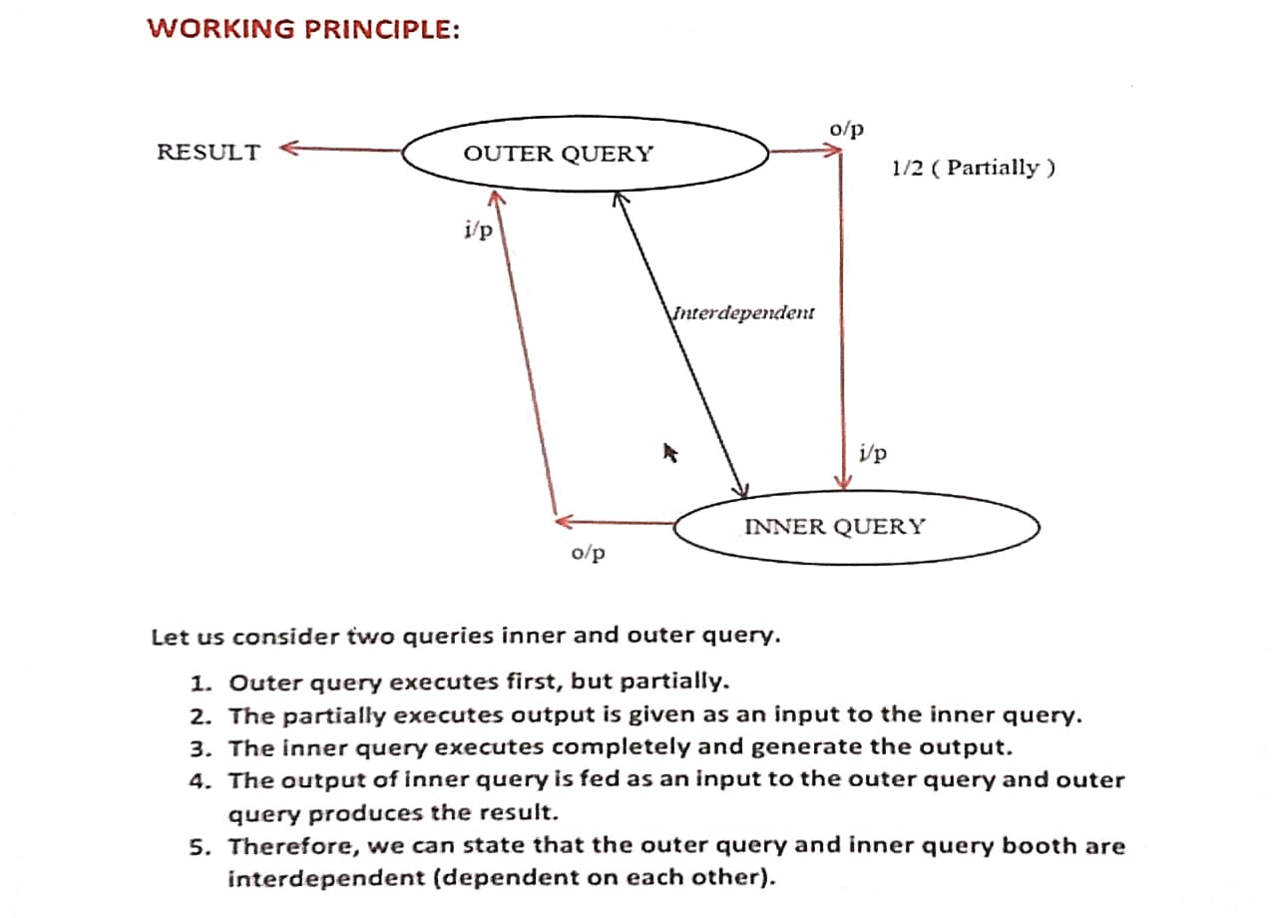

NOTE:
i. In co-related sub query a Join condition is a must, and must be written only in the Inner Query.
ii. Co-Related sub query works with the principles of both SUB QUERY & JOINS.

Difference Between Subquery and Co-Related Subquery
SUB QUERY | CO-RELATED SUB QUERY
Inner query executes first | Outer query executes first
Outer query is dependent on inner query | Both are interdependent
Join condition not mandatory | Join condition is mandatory and must be written in inner query
Outer query executes Once | Outer query executes Twice

Atm
Csh withorw (current and withoro){current balane with success message}
Insufficient balance exception

